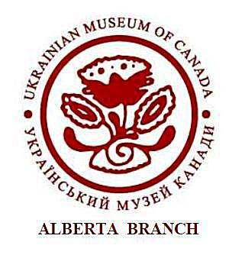
UKRAINIAN MUSEUM OF CANADA, ALBERTA BRANCH
OF THE UKRAINIAN WOMEN’S ASSOCIATION OF CANADA

УКРАЇНСЬКИЙ МУЗЕЙ КАНАДИ, АЛЬБЕРТІЙСЬКА ФІЛІЯ
Союзу Українок Канади

10611-110 Avenue Edmonton, AB, T5H 1H7
Phone: 780-441-1062 / Website: umcalberta.org / Email: info@umcalberta.org

MEMBERSHIP APPLICATION/RENEWAL FORM
Ukrainian Museum of Canada – Alberta Branch
10611-110 Avenue
Edmonton, AB T5H 1H7
Phone: 780-441-1062 / Website: umcalberta.org / Email: info@umcalberta.org

Name :____________________________________________________________
Address :__________________________________________________________
City :_______________________ Province :_____________________________
Postal Code :______________________
Email Address :______________________________ Phone:_________________

Amount Paid: $ for the year(s)
I would like to volunteer (Y/N)

Membership $20.00 per year ($10.00 will be forwarded to Ukrainian Museum of Canada in Saskatoon).

Membership entitles you to entry & membership privileges in all of the Ukrainian Museum of Canada branches (Saskatoon, Toronto, Winnipeg, Vancouver, Calgary and Edmonton).

Payment can be made by cheque made out to UMC Alberta or by e-transfer. See addresses above.

