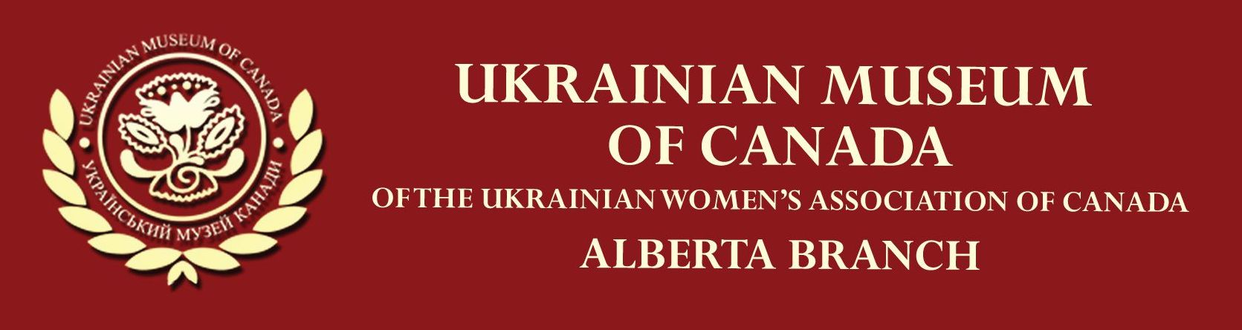

FALL/WINTER JOB OPPORTUNITY
Position: Office Administrator, Curatorial Assistant
The Ukrainian Museum of Canada, Alberta Branch offers part-time employment as an Office Administrator and Curatorial Assistant for the period October 2022 to March 2023. The position provides valuable, practical experience to individuals who wish to work in the field of Ukrainian heritage in a museum holding a large collection of cultural artifacts. A permanent heritage organization, the Museum collects, preserves and makes accessible to the public information that pertains to Ukrainian Canadian heritage.
On a part-time basis fulfilling 180 hours over the period October 2022 to March 2023, the individual will work closely with the museum operations, in particular the internet and website. The museum is recruiting a mature, proactive individual who possesses knowledge and an appreciation of Ukrainian cultural heritage, and is able to perform computer functions required for the operation of the museum. The employment hours will be set in agreement between the applicant and the museum.
Responsibilities and Duties
- Assist with ethnographic research required in cataloguing information and mounting displays and exhibits
- Digitally input information related to the museum collection
- Utilize social media platforms (FACEBOOK, Instagram) to publicize the museum and its activities
- Update museum website and input data to enhance communication
- Communicate and report regularly to museum board members
- Perform other duties as required and agreed upon
Qualifications
- Self-starter, organized, resourceful, able to work independently
- Superior communication skills including familiarity and skillful with virtual forms of communication and social media
- Advanced computer skills that enable inputting certain types of data and updating social media platform content
- Ability to operate office machines and proficiency with computer applications (Microsoft Office, databases, etc.)
- Competency with website design and maintenance
- Working knowledge of the Ukrainian language (reading, speaking)
- General knowledge of Ukrainian ethnography
- Interest and appreciation for heritage culture, Ukrainian in particular
- Able to assist in historical and ethnographic research, understand and summarize relevant information for museum use
- Experience working in a Ukrainian cultural environment an asset
Location: Ukrainian Museum of Canada, Alberta Branch
10611 – 110 Avenue, NW
Edmonton, Alberta
Contact: Submit application and accompanying resume and two references to Elaine Harasymiw at elainelvh@telus.net. For further information regarding this position, phone same at 780 437-6629.
The Museum is committed to equity in all its policies, practices and procedures. This position is subject to funding through the Department of Canadian Heritage, Government of Canada.
We welcome applications from all qualified individuals.

